**Step 1 – Creating the scene**

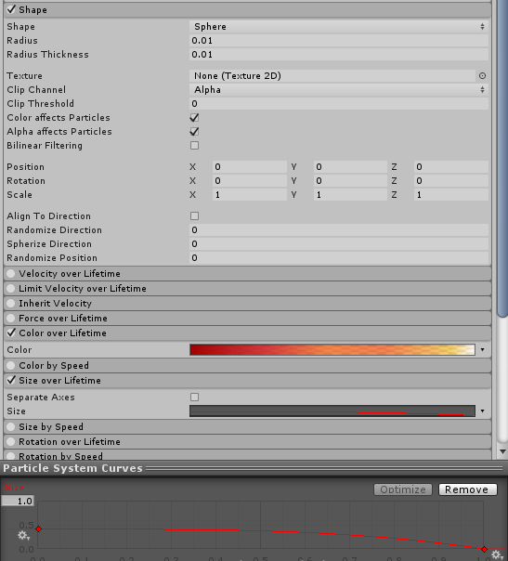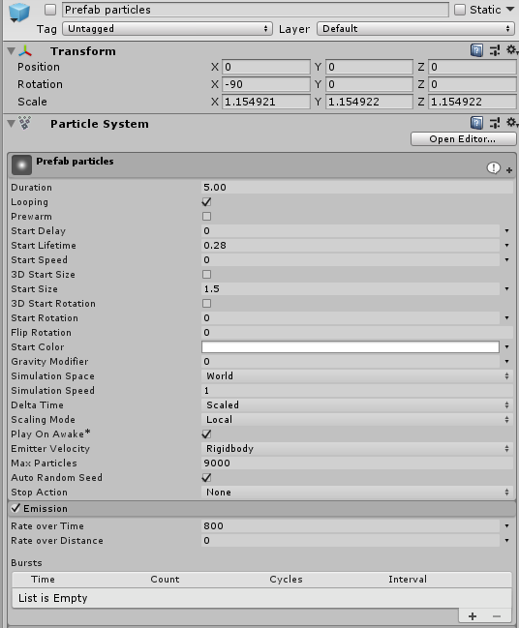To begin you will need to construct a brand-new prefab. It will have all of the things the old prefab had, except it will include a Particle Effect System. This particle effect system will work in correspondence with the particle effect enable script that will be touched upon later on in this tutorial. However, the most important part is that the particle system **must** be a **child** of the spherical prefab, otherwise this will not work! With that said, the particle effect will have the following properties:

Keep in mind: the colour over lifetime does not need to be the same as shown in the example here. However, it is advised that the alpha of the colour decreases over the end of its lifetime for the best visual effect. Another important thing to note is that the particle effect must be **disabled** on the prefab. This is so that it can subsequently be enabled via; the script that will be spoken about in the third step.

**Step 2 – Prefab destroy script**

The prefab destroy script is incredibly simple as it is merely a collision script used to destroy a particular object tagged projectile. This script will be attached to the **cube** the player is trying to defend. The script looks as such:

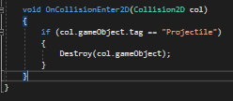

**Step 3 – Particle effect enable script**

The particle effect script is yet another simplistic script to create. All it does is enable the Particle System component found on the object in question when hit by the player. It will look like the following:

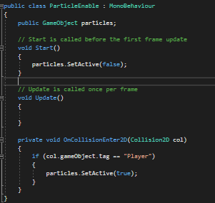

As you can see, all this script does is set the particle effect as false right away at the start of the game, of which it will then active should the prefab (of which this particle effect/script is attached to) come into contact with the object tagged as “Player”, which is our capsule.